**Deploying Open5g applications on Kubernetes with continuous integration**

**(Akhil Reddy Nalla, 811172556,** [***analla3@kent.edu***](mailto:analla3@kent.edu)**)**

**(Divya Sri Karingula, 811172271 -** [**dkaringu@kent.edu**](dkaringu@kent.edu%20) **)**

**Introduction:**

* This Open5g can be used to configure your own NR/LTE network. If gNB/eNB and USIM are available, you can build a private network using Open5GS.
* Open5GS implemented 5GC and EPC using C-language and WebUI is provided for testing purposes and is implemented in Node.JS and React.

**Project Statement & Solution:**

**Problem**: Open5g Application developers can repeatedly build, test, and deploy newer versions of their applications, no matter where they are running and without any focus on Provisioning, Deploying Updating, Upgrading, availability & scalability

**Solution**: The main goal of this project is to create a platform to maintain Continuous integration, Continuous deployment, and continuous testing for an Open5g system over cloud

**Recap of Milestone 1:** we have discussed how the developer will create a branch to push their code in our repository.

Set up Ec2 instances: Create a region and navigate to EC2 console and then create an EC2 instances.

Set up Ubuntu machines: we have setup a Ubuntu machine in EC2 instance.

Set up Docker Engine: you need to install the **Docker Desktop Installer.exe** Normally, it downloads to Downloads folder, but we can also launch it from the recent downloads menu in our web browser.

Set Jenkins instance: Launch an EC2 instance, install Jenkins on it, and set up Jenkins so that it will automatically spin up Jenkins agents whenever the instance needs to expand its build capacity.

Creating a docker script and downloading the components from GitHub.

**Tools**

* Git
* GitHub Code Repo
* AWS Management Console
* AWS Service like Ec2,
* Docker Engine
* Docker Hub Registry
* Jenkins

**Docker Images**

Sudo docker images: list all the images build with given docker file & docker compose

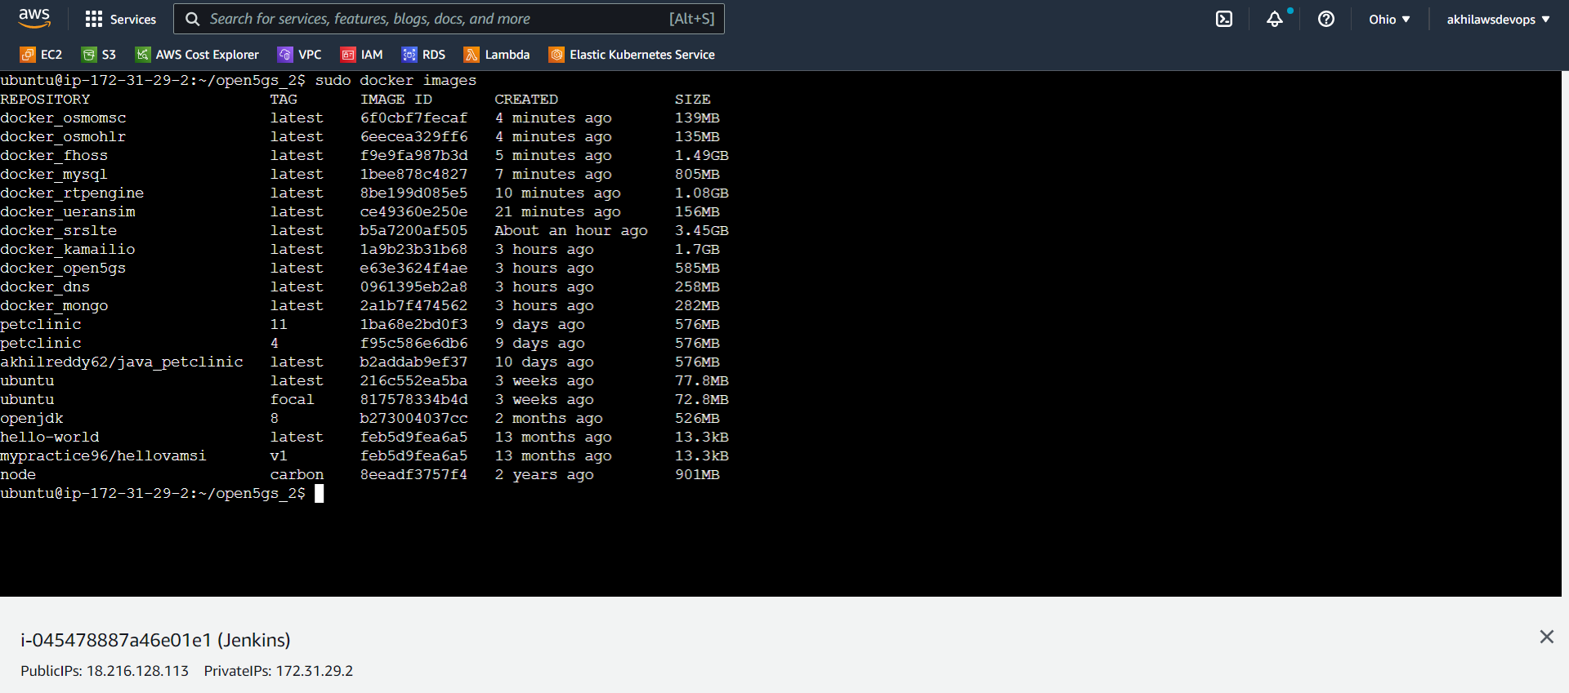

**Docker Containers**

Sudo docker ps : list all the container which are in active state

Sudo docker ps -a : list all the container which are in active & exited state

**Jenkins**

For pipeline we have created four stages as show below:

1. Clone the code from GitHub Repository
2. Stop the previous container that were build using docker compose
3. Build base images of open5gs, kamailio, ueransim & srslte
4. Build and Run using docker-compose

**Jenkins Configuration file**

Below is Jenkins pipeline script to build CI/CD Pipeline to run Open5g application

pipeline {

agent any

stages {

stage('clone the code from repo') {

steps {

git 'https://github.com/AkhilReddy62/open5gs_2.git'

}

}

stage('Stop docker-compose'){

steps {

sh 'docker-compose stop'

sh 'docker-compose rm'

sh 'docker network rm open5gs_2_default || true'

}

}

stage('build base dockerimage of open5gs, kamailio, ueransim') {

steps {

dir('base') {

sh "pwd"

sh 'docker build -t docker_open5gs .'

}

dir('ims_base') {

sh "pwd"

sh 'docker build -t docker_kamailio .'

}

dir('srslte') {

sh "pwd"

sh 'docker build -t docker_srslte .'

}

dir('ueransim') {

sh "pwd"

sh 'docker build -t docker_ueransim .'

}

}

}

stage('Build and Run using docker-compose'){

steps {

sh 'ls -a'

sh 'set -a'

sh '''#!/bin/bash

source .env

'''

sh 'docker-compose build '

sh 'docker-compose up -d'

sh 'docker rmi $(docker images -f "dangling=true" -aq)'

}

}

}

}

**Reference**

1. <https://github.com/open5gs/open5gs>
2. Nikolaos Apostolakis, Marco Gramaglia, and Pablo Serrano - Design and Validation of an Open-Source Cloud Native Mobile Network
3. <https://open5gs.org/open5gs>
4. <https://medium.com/rahasak/5g-core-network-setup-with-open5gs-and-ueransim-cd0e77025fd7>
5. Docker Hub Account: <https://hub.docker.com/u/akhilreddy62>
6. GitHub Repo link: <https://github.com/AkhilReddy62/open5gs_2>